Document:- SPI testing report

Author:- Sarang Waje

Date:-15/01/2024

__________________________________________________________________________________

Setup

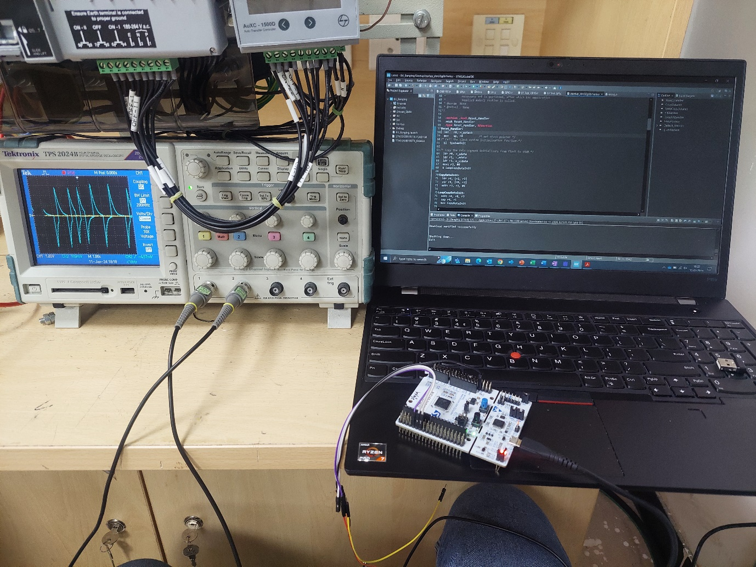

STMG0B1RE NECLEO board is used for implementing Bit Banging of SPI Communication protocol.

The Output of MOSI and Clock pin has been observed on DSO.

Chip Select (NS) and MISO pin have been ignored during this trial.

Problems observed in this observed.

Firmware challenges: - Exact timings could not set, so observed the signal at very low random frequency for checking the logic. Timing needs to be improved.

1. Bit is set but it cannot maintain the set level and signal decays. Confirmed the ODR register for status of the PIN, indicates the pin is set, but on the DSO it decays, timing is the issue(also tried to take MISO output on the LED, the LED glows full according to the Byte.
2. For pulling the pin to GND, DSO shows a negative spike.
3. Did not test MISO pin as could not get a input signal.

Doubts: -

For MOSI: how the sequence should be, should the clock toggle and then the bit should update or the other way round.

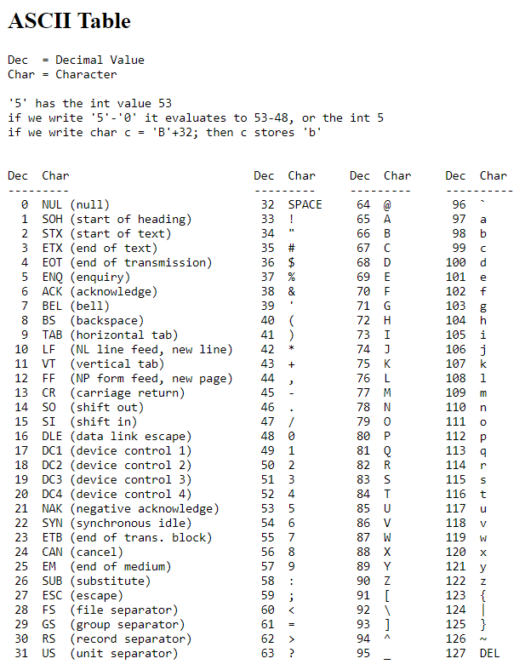

Figure .ASCII table for reference

Bit transfer

1. ‘H’ 72 (0b0100 1000)

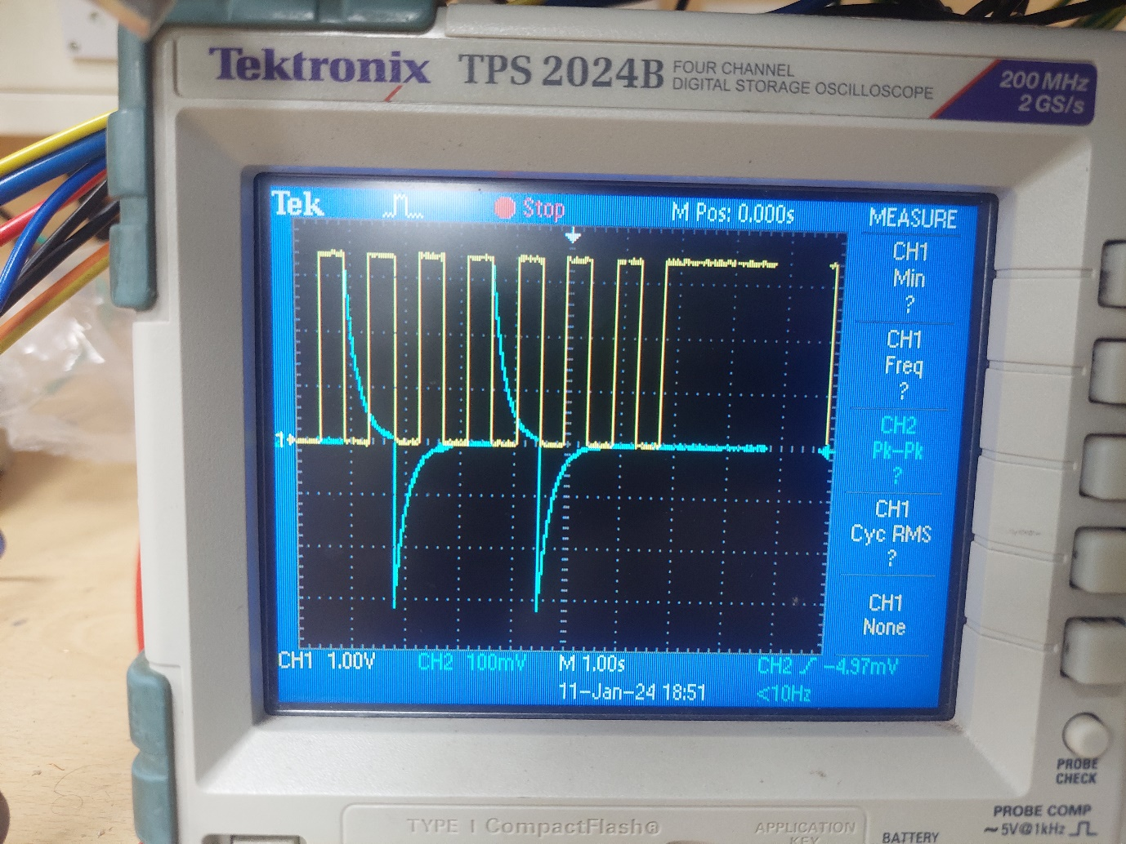

Figure .Sending 'H' character (0b0100 1000). MISO in blue, Clock in yellow.

CPOL=1

CPHA=1

1. Sending ‘i’ 105 (0b0110 1001)

Figure .Sending character 'i' (0b01101001). MOSI in blue, Clock in yellow.

1. Sending Half word “Hi” 72 , 105 (0b0100 1000 0110 1001 ) in CPOL=1, CPHA=1

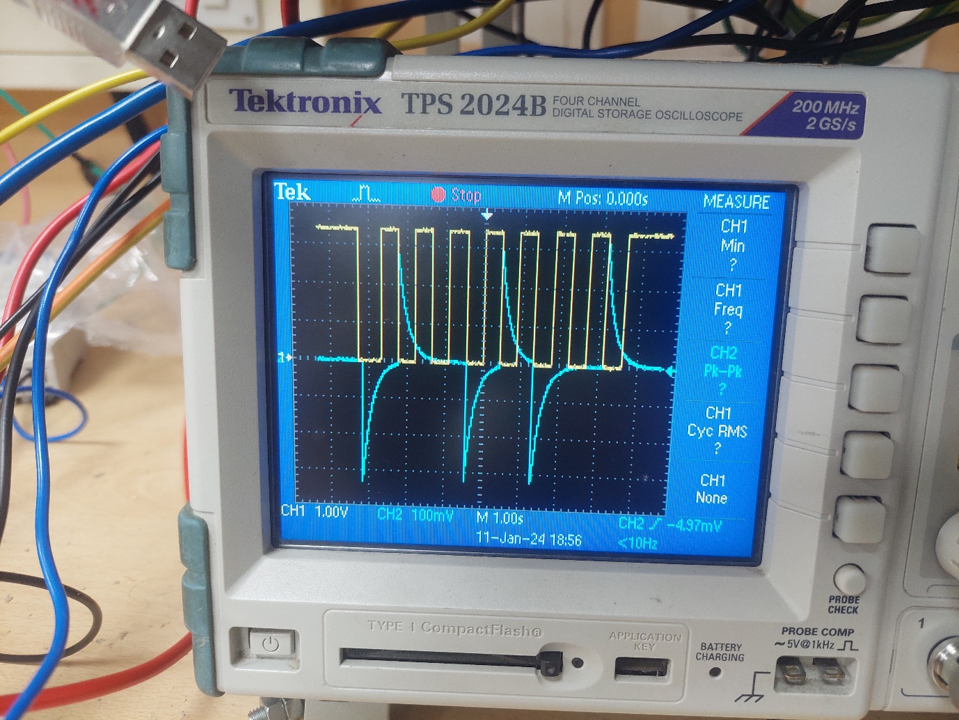

Figure .Sending "Hi". MOSI in Blue, Clock in yellow.

CPOL=1, CPHA=1

1. Sending Half word “Hi” 72 , 105 (0b0100 1000 0110 1001 ) in CPOL=1, CPHA=0

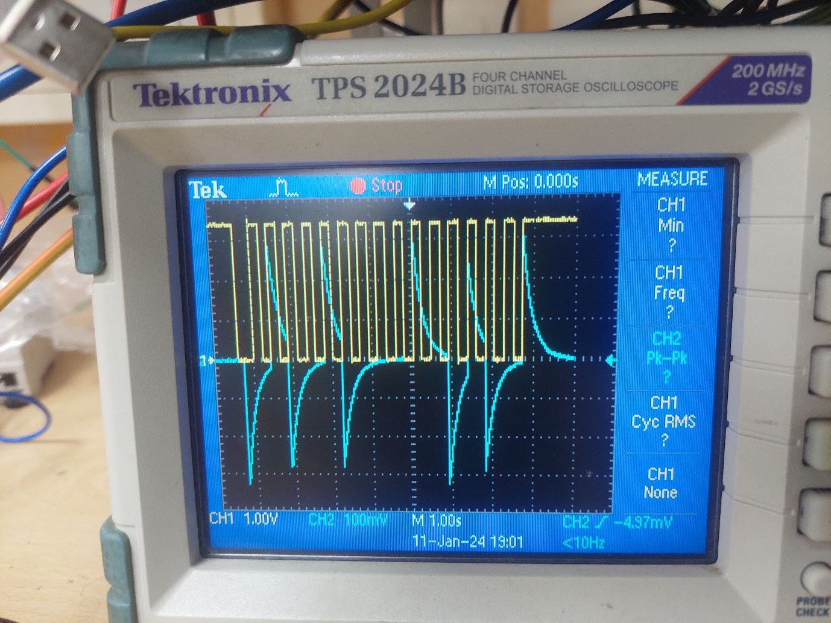

Figure .Sending "Hi" . MOSI in blue, Clock in yellow.

CPOL=1, CPHA=0

1. Sending Half word “Hi” 72 , 105 (0b0100 1000 0110 1001 ) in CPOL=0, CPHA=1

Figure .Sending "Hi". MOSI in blue, Clock in yellow.

CPOL=0, CPHA=1

1. Sending Half word “Hi” 72 , 105 (0b0100 1000 0110 1001 ) in CPOL=0, CPHA=0

Figure .Sending "Hi". MOSI in Blue, Clock in yellow.

CPOL=0, CPHA=0